**Demand Builder:**

Demand Builder is a tool that automates the creation and alteration of demand files.

Demand files are used as inputs to the MARATHON model.

Note: Excel cell VLOOKUPs and? functions are not supported by this tool. If you have any in the input workbooks, you will get an error that reads “not implemented yet”.

**Inputs:**

**Vignette Mapping File:**

The vignette mapping file describes the start and duration time for each type of demand (vignettes and FORGE).

The header column needs to contain the fields: *ForceCode*, *StartDay*, and *Duration*. Additional columns can be present and do not need to be removed. The ordering of these columns does not matter.

*Example File*:

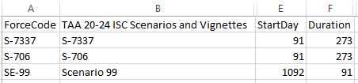

**Vignette Consolidated File:**

The vignette consolidated file describes constant demand of which SRCs are required in each vignette. Vignettes are demands with a constant quantity.

The header column needs to contain the fields: *ForceCode*, *SRC*, *Title*, *Strength*, *Quantity*, and *Title10_32*. Additional columns can be present and do not need to be removed. The ordering of these columns does not matter.

*Example File:*

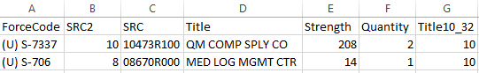

The Vignette Consolidated and Vignette Mapping file are joined on the ForceCode name. Sometimes the classification of the vignette unclassified (U)/ secret (S) is given in front of the ForceCode; this is allowed and will not cause any issues. Apart from potentially having a classification in one file and not the other, the ForceCode values in Vignette Mapping file have to match exactly to what is in the Vignette Consolidated file. If there is a mismatch between the files, the all data for that Vignette or Scenario will not be in the final output file.

Only events listed in the map are put into the final file. If a vignette is not present in the mapping file, but exist in the consolidated file, it will not be in the final demand record. Similarly, if a vignette is listed in the map but there is not corresponding data in the consolidated file, it will not appear in the final demand record.

SRCs that are not in the MAP but are in the CONSOLIDATED, or not in the CONSOLIDATED but in the MAP will be logged in the *out-of-scope.txt* file in the output directory.

**FORGE Files:**

Each scenario that has a demand will have its own FORGE file.

The FORGE files describe the quantity of SRCs needed over multiple periods of time. Typically, each time period is 8 days.

Demand Builder supports either the Unit_Node_Detail sheet (RECOMMENDED) or the SRC_By_Day sheet.

*Unit_Node_Detail sheet*:

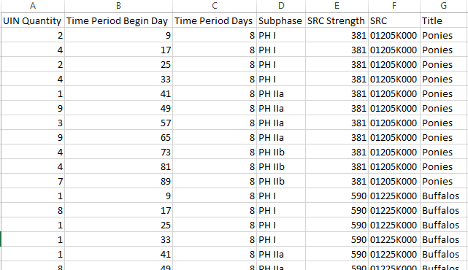

*The sheet name should be “Unit_Node_Detail”, which should be the default in the FORGE file.

*SRC_By_Day sheet:*

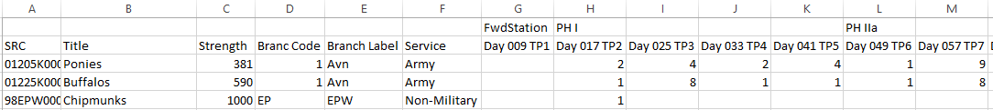

*This sheet is supported, but should be used second to Unit_Node_Detail. Only use when Unit_Node_Detail is missing or corrupted.

*The sheet name should be “SRC_By_Day”, which should be the default in the FORGE file.

**Working Directory:**

Once all files are in the correct format, they should all be moved to a single folder. This folder will be referred to as the working directory within demand builder.

**Running Demand Builder**

When demand builder is ran, the user should see this screen:

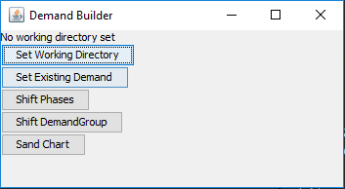

The first step is to set the working director by clicking the button. This will open a file select menu which the user should use to locate their working directory folder (or any file within that directory) where they moved all of the formatted inputs to.

The working directory can be changed at any point.

After locating the working directory, the user will be prompted to confirm that the auto-generated meta data associated with each file is correct.

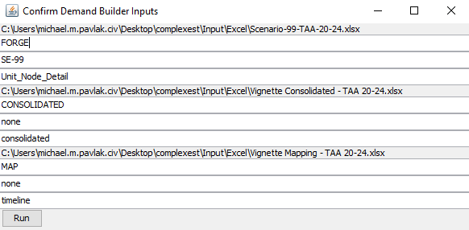

Each label list the full file path. The subsequent text fields are for the file type (FORGE, CONSOLIDATED, or MAP), ForceCode*, and Excel sheet name.

*The ForceCode only applies to FORGE/Scenario data and should match what is listed in the MAP file.

Pressing run will generate the Demand Records and additional logs and re-formatted inputs. This file will be located in the working directory, which will be listed at the top of the demand builder GUI.

If the file was successful built, a dialog box will appear indicating which files were used as inputs.

New file will be created in the set working directory with the name [path]_DEMAND.txt, where path is the last subfolder in the working directory path.

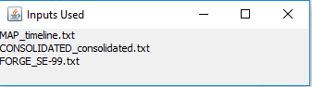

If any errors occur, any error message or stack trace will be displayed to the user in the error message GUI.

*Example of error message:*

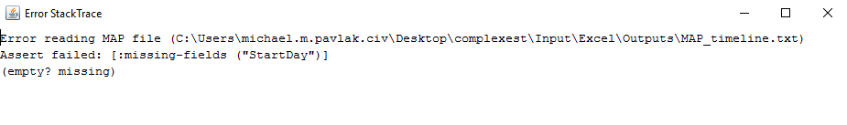

If an error occurs while trying to build demand, without closing demand builder, the user can manually fix the inputs based on the error message.

*If Excel is used to adjust an input file, make sure it is closed before trying to run again. Excel blocks all other processes from reading any open files.

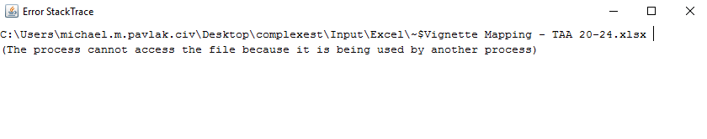

Users can also import existing Demand Records by using the ‘Set Existing Demand’ button, which will prompt the use for the location of the Demand file.

In addition to creating new demand files, demand builder can change the newly created or already existing demand files in two different ways:

The first demand file adjustment that a user can specify is a systematic change in the start day of duration of a demand group. This can be done by clicking the Shift Times button while in a working directory that contains an existing demand file. A new window will appear;

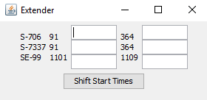

The first column indicates the demand group. The second column indicates the starting time. The final column indicates the ending time. The first text box will allow the user to adjust all start times by a given amount. The second text box will shift ending times by any given amount. Negative values are used to bring something forward in time. Positive values shift something to a later point. Empty cells have no effect and will be ignored. Clicking the Shift Start Times button will update the existing demand file. If at any point the original file needs to be restored, it can be rebuilt by going back to the build demand step.

If phase timings within a scenario need to be updated, the user can do so through the phase shifter tool. Clicking the Shift Phases button will open a new window:

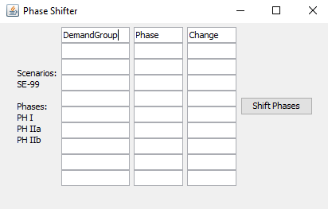

The DemandGroup column is the Scenario to be adjusted. The phase is the phase. The Change is the amount to shift (sign indicates direction). *Do not edit the first column. Changes to phases are done in order and are cascaded. For more specific information about how phase shifter works, see phase shifter documentation [here]. If there are any errors shifting the phases, the user will be notified with a new window with the detailed error message.

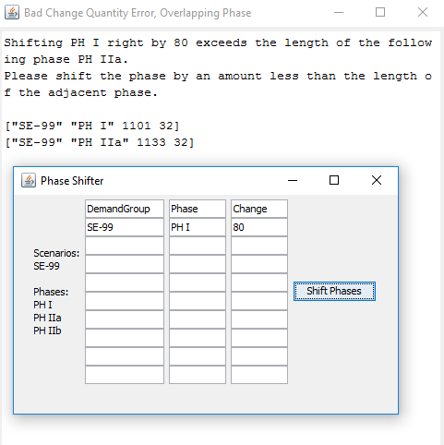

If no error message occur, the change will be made to the demand file and the phase shifter window will disappear.

The final functionality of Demand Builder is the ability to generate sand charts which indicate total personnel over time, grouped by demand group. This can be done by clicking the Sand Chart button.

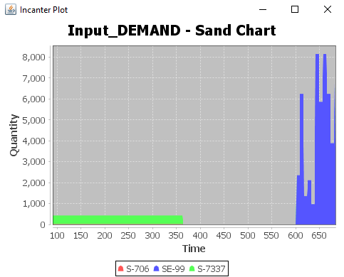

Charts are not automatically saves. The image can be save by right clicking save-as on the plot window.